# Summary Investment Analysis

# MSc Economics

# 2017 - 2018



## Lecture 1 – slides

Investment leads to reduced current consumption, and planned later consumption.

Two types of assets:

* Real assets: assets used to produce goods and services (machinery) – 31%.
* Financial assets: claims on real assets – 69%.

Financial markets:

* Play a central role in the allocation of capital resources.
* Allow for timing of consumption.
* Allocate risks.
* Separate ownership and management.
  + Agency issues: managers prefer money over shareholders’ satisfaction.
  + American/Anglo-Saxon view: do what is best for shareholders.
  + Continental view: do what is best for the long-term.

Accounting scandal:

* Business scandals which arise from intentional manipulation of financial statements with the disclosure of financial misdeeds by trusted executives of corporations or governments.

Analyst scandal during the dot.com-crisis.

* Analysts provide earnings forecasts for companies.
* Furthermore, they give recommendations on whether to buy or sell stocks.
* Dot.com-crisis: analysts said that internet stocks were ‘golden’, while in fact they were crap.

Active vs passive investments:

* Active: purchase investments and continuously monitor their activity in order to exploit profitable conditions.
  + Mispricing: the current price is wrong according to ‘your’ model.
  + Timing the market: find the right time to sell or buy a stock.
* Passive: aims to maximize returns over the long run by keeping the amount of buying and selling to a minimum.
  + No attempt to find undervalued securities.
  + No attempt to time the market.
  + Holding a highly diversified portfolio.
  + Avoid trading costs and management fees.
  + Increasingly popular.

Example of consumption timing

Two periods, income of $10,000 in each period, able to save and borrow at 5% interest.

Three options:

* A: Save all money in the first period, consume everything in the second period.
  + Save $10,000 at 5% leads to a consumption of $20,500 in the second period.
* B: Consume $10,000 in both periods.
* C: Consume everything now and nothing in the second period.
  + Borrow $10,000 at a 5% interest rate: 10,000/1.05 = $9,524.
  + Total consumption in period 1 = $19,524.

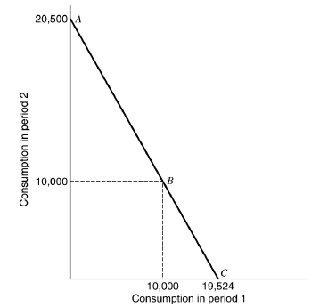 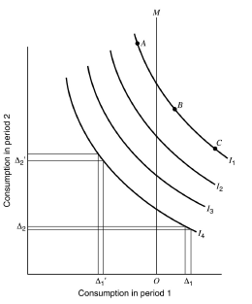 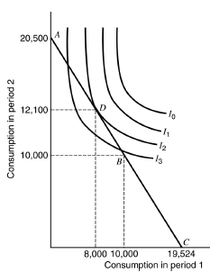

Adding indifference curves:

* These curves represent the investors’ preference for consumption in the two periods.
* Curves are constructed so that everywhere along the curve, the investor is equally happy.
* .
* If you don’t have much consumption in period 1, extra consumption in this period requires larger efforts of period 2 consumption.

## Lecture 1 – boek (CH1)

Real assets of the economy: land, building, machines, and knowledge that can be used to produce goods and services. They generate net income to the economy.

Financial assets: claims to the income generated by real assets, such as stocks or bonds. They define the allocation of income or wealth among investors.

* Fixed income: promise of either a fixed stream of income or a stream of income determined by a specified formula.
* Equity: represents an ownership share in the corporation.
* Derivative securities provide payoffs that are determined by the prices of other assets such as bonds or stock prices.

Portfolio: collection of investment assets.

Diversification means that many assets are held in the portfolio so that the exposure to any particular asset is limited.

Major players in financial markets:

* Firms are net demanders of capital.
* Households are net suppliers of capital.
* Governments can be borrowers or lenders, depending on the relationship between tax revenue and government expenditure.

Financial intermediaries have evolved to bring the suppliers of capital together with the demanders of capital. These intermediaries issue their own securities to raise funds to purchase the securities of other corporations.

* Primary social function: channel funds from households savings to the business sector.

Profit of financial intermediaries equal the spread between the interest rates paid to depositors, and the rates charged to borrowers.

Advantages of financial intermediaries:

* By pooling resources of many small investors, they are able to lend considerable sums to large borrowers.
* By lending to many borrowers, intermediaries achieve significant diversification, so they can accept loans that individually might be too risky.
* Intermediaries build expertise through the volume of business they do and can use economics of scale and scope to assess and monitor risk.

Investment bankers handle the marketing of the security in the primary market, where new issues of securities are offered to the public.

Later, investors can trade previously issued securities among themselves in the so-called secondary market.

Venture capital: financing that investors provide to start-up companies and small businesses that are believed to have long-term growth potential. Sources: capital funds, wealthy individuals and institutions such as pension funds.

Private equity: capital that is not noted on a public exchange. Private equity is composed of funds and investors that directly invest in private companies, or that engage in buyouts of public companies, resulting in the delisting of public equity.

Summary CH1:

Real assets create wealth. Financial assets represent claims to parts or all of that wealth. Financial assets determine how the ownership of real assets is distributed among investors.

Financial assets can be categorized as fixed income, equity, or derivative instruments. Top-down portfolio construction techniques start with the asset allocation decision (the allocation funds across broad asset classes) and then progress to more specific security-selecting decisions.

Competition in financial markets leads to a risk-return trade-off, in which securities that offer higher expected rates of return also impose great risks on investors. The presence of risk, however, implies that actual returns can differ considerable from expected returns at the beginning of the investment period. Competition among security analysts also promotes financial markets that are nearly informationally efficient, meaning that prices reflect all available information concerning the value of the security. Passive investment strategies may make sense in nearly efficient markets.

Financial intermediaries pool investor funds and invest them. Their services are in demand because small investors cannot efficiently gather information, diversify, and monitor portfolios. The financial intermediary sells its own securities to the small investors. The intermediary invests the funds thus raised, uses the proceeds to pay back the small investors, and profits from the difference (=spread).

Investment banking brings efficiency to corporate fund-raising. Investment bankers develop expertise in pricing new issues and in marketing them to investors. By the end of 2008, all the major stand-alone US investment banks had been absorbed into commercial banks or had reorganized themselves into bank holding companies. In Europe, where universal banking had never been prohibited, large banks had long maintained both commercial and investment banking decisions.

## Lecture 1 – boek (CH2)

Money market instruments include short-term, marketable, liquid, low-risk debt securities.

They are often called cash equivalents.

Capital market instruments include longer term and riskier securities.

Securities in this market are much more diverse than those found within the money market.

Ask price: the price you would have to pay to buy something.

Bid price: the price you would receive if you wanted to sell something.

The bid price is slightly below the ask price.

Bid-ask spread is the difference between these prices, which is also the dealer’s source of profit.

Mortgage-backed securities are either an ownership claim in a pool of mortgages or an obligation that is secured by such a pool.

* Conforming mortgages: the loans satisfy certain underwriting guidelines, such as the credit-worthiness of the borrower, before they may be purchased by Fannie Mae or Freddie Mac.
* Subprime mortgages: riskier loans made to financially weaker borrowers that were bundled and sold by private-label issuers.

Common stocks represent ownership shares in a corporation. Each share of common stock entitles its owner to one vote on any matters of corporate governance that are put to a vote at the corporation’s annual meeting, and to a share in the financial benefits of ownership.

* Residual claim: stockholders are the last in line of all those who have a claim on the assets and income of the corporation.
* Limited liability: shareholders can only lose their original investment in the event of failure of the corporation.

Preferred stock: a class of ownership in a corporation that has a higher claim on its assets and earnings than common stock.

Derivatives markets:

* Options: the contract offers the buyer the right, but not the obligation, to buy (call) or sell (put) a security or other financial asset at an agreed-upon price (the strike price) during a certain period of time or on a specific date (exercise date).
* Futures: contracts obligating the buyer to purchase an asset or the seller to sell an asset, such as a physical commodity or a financial instrument, at a predetermined future date and price.

Summary CH2:

Money market securities are very short-term debt obligations. They are usually highly marketable and have relatively low credit risk. Their low maturities and low credit risk ensure minimal capital gains or losses. These securities trade in large denominations, but they may be purchased indirectly through money market funds.

Mortgage pass-through securities are pools of mortgages sold in one package. Owner of pass-throughs receive the principal and interest payments made by the borrowers. The originator that issued the mortgages merely serves it, simply “passing through” the payments to the purchasers of the mortgage. A federal agency may guarantee the payments of interest and principal on mortgages pooled into its pass-through securities, but these guarantees are absent in private-label pass-throughs.

Common stock is an ownership share in a corporation. Each share entitles its owner to one vote on matters of corporate governance and to a prorated share of the dividends paid to the shareholders. Stock, or equity, owners are the residual claimants on the income earned by the firm.

Preferred stock usually pays fixed dividends for the life of the firm: it is a perpetuity. A firm’s failure to pay the dividend due on preferred stock, however, does not precipitate corporate bankruptcy. Instead, unpaid dividends simply cumulate. Newer varieties of preferred stock include convertible and adjustable-rate issues.

Call options are the rights to purchase an asset at a stipulated exercise price on or before an expiration date.

Put options are the rights to sell an asset at some exercise price.

Calls increase in value while puts decrease in value as the price of the underlying asset increases.

Futures contracts are obligations to buy or sell an asset at a stipulated futures price on a maturity date. The long position, which commits to purchasing, gains if the asset value increases while the short position, which commits to delivering, loses.

## Lecture 2 – slides

The investment process describes how an investor should go about making decisions with regard to:

* What marketable securities to invest in.
* How extensive the investments should be.
* When the investments should be made.

Five steps of the investment process:

1. Investment policy.
   1. Objective: wedding, car, retirement?
   2. Determine amount of investable wealth (depends on income).
      1. Mission statement in terms of long-run financial goals and risk.

Factors that affect risk:

* + - 1. Maturity of an instrument: longer maturity 🡪 riskier.
      2. Risk characteristics and creditworthiness of the issuer or guarantor of the investment.
      3. The nature and priority of the claims the investment has on income and assets (bonds > shares).
      4. Liquidity of the instrument and in which type of market it is traded.
  1. Active vs passive management.
  2. Where to invest in?
     1. Asset allocation.
     2. Security allocation.

1. Security analysis:
   1. Find mispriced securities.
   2. Fundamental analysis: intrinsic value should equal discounted present value.
   3. Compare current market price to true market value.
   4. Identify undervalued securities and time the trade!
2. Construct a portfolio:
   1. Identify specific assets and proportion of wealth in which to invest.
   2. Address issues of selectivity, timing and diversification.
3. Portfolio revision:
   1. Periodically repeat step 3.
   2. Determine your expected return relative to risk.
      1. Are there other securities which have a more favourable trade-off?
   3. Be aware of loss aversion: many people don’t want to sell ‘losing’ stocks.
   4. Revise if necessary:
      1. Increase/decrease existing securities.
      2. Delete some securities.
      3. Add new securities.
4. Portfolio performance evaluation:
   1. Involves periodic determination of portfolio performance with respect to risk and return.
   2. Requires appropriate measures of risk and return.

Trading of securities.

IPO: the first time that the stock of a private company is offered to the public.

IPO process:

* Roadshows.
* Meetings with institutional investors.
* Determining price range.
  + Company likes a high price range, as it is their revenue.
  + Issuer likes a low price range, as they do not want institutional investors to overpay, and sequentially losing them as their customers.
* First day of trading.
  + On average, the first-day return is always positive.

Type of markets:

* Direct search: least organised.
* Brokered: trading in a good is active.
* Dealer: trading in a particular type of asset increases.
* Auction: most integraded.

Types of orders:

* Market orders: bid/ask price.
* Price-contingent.
  + Limit buy: buy if and when stock may be obtained at or below a given price.
  + Limit sell: sell if and when stock price rises above a specified limit.
  + Stop-loss: the stock is to be sold if its price falls below a specified limit.
  + Stop-buy: a stock should be bought when its price rises above a limit.

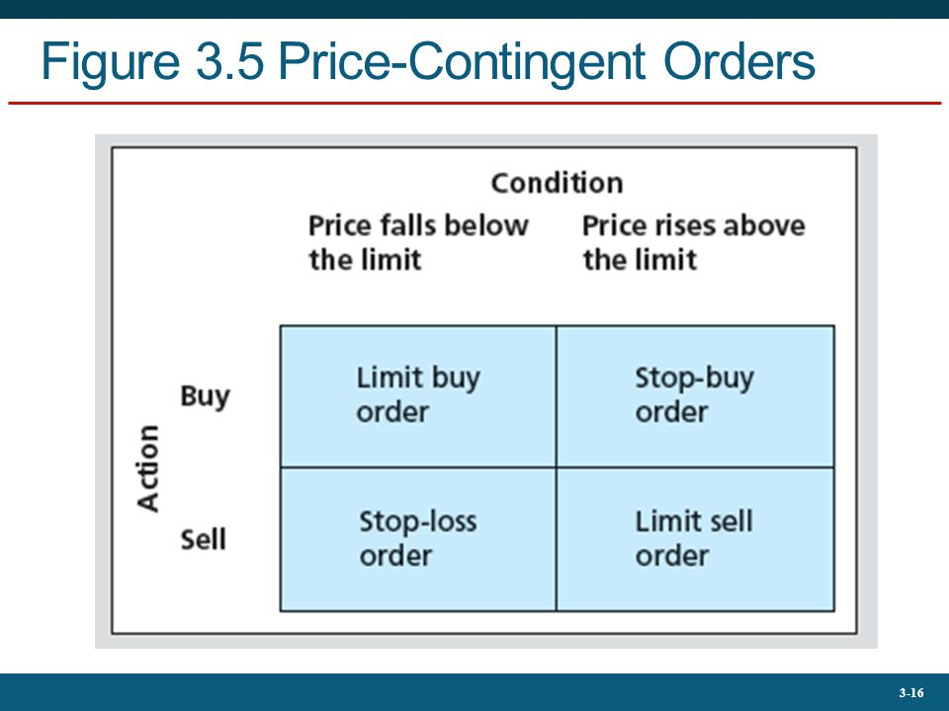

Tabel - Price-Contingent Orders

High frequency trading: a type of algorithmic trading characterized by high speeds, high turnover rates, and high order-to-trade ratios that leverages high-frequency financial data and electronic trading tools.

* HFT firms are gaming the market in doing anything they can to be first in the market. It is all about being first.

Typical flow of an order:

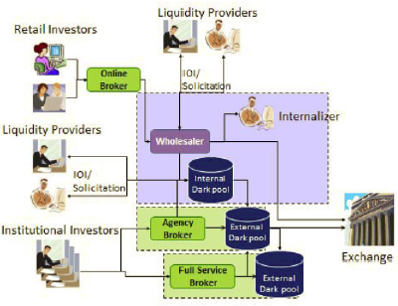

Dark pool: a private financial forum or exchange for trading securities.

* Give investors the opportunity to place orders and make trades without publicly telegraphing their intentions until the sale has been executed.
* Primary advantage: institutional investors making large trades don't have to show their hand during the process of finding buyers and sellers.
* Primary disadvantage: pool participants might not get the best price due to the lack of transparency.

## Lecture 3 – slides

No slides.

## Lecture 4 – slides

Timeline of the financial crisis:

* 2000-2006: sharp increase in housing prices caused many investors to believe that continually rising home prices would bail out poorly performing loans.
* 2004: interest rates began rising.
* 2006: home prices peaked.
* 2007: housing defaults and losses on mortgage-backed securities surged.
* 2007: Bear Stearns announces trouble at its subprime mortgage-related hedge funds.
* 2008: troubled firms such as Bear Stearns, Fannie Mae, Freddie Mac, Merrill Lynch, Lehman Brothers and AIG.
  + Money market breaks down.
  + Credit markets freeze up.
  + Federal bailout to stabilize financial system.

Antecedents of the financial crisis:

* The Great Moderation: the US had a stable economy with low interest rates and a time business cycle with only mild recessions.
* Historic boom in the housing market.

The problem was that people who couldn’t actually buy a house, were given a mortgage anyway.

* This was done on a refinancing basis: low interest rate in the first 2 years, then a new interest rate was set. This new interest rate negatively correlates with the change in the price of the house.
* If price went up, interest rate stayed the same 🡪 able to refinance. Problem if prices froze.
* NINJA loans: no income no job or assets loan.

Strategic default: the decision by a borrower to stop making payments on a debt, despite having the financial ability to make the payments.

* The debt owed is larger than the value of the asset.
* Main advantage: stop paying your mortgage, get a house across the street if house prices went down.
* Disadvantage: lower credit score.

Changes in Housing Finance:

|  |  |
| --- | --- |
| **Old Way** | **New Way** |
| Local thrift institution made mortgage loans to home owners | Securitization: Fannie Mae and Freddie Mac bought mortgage loans and bundled them into large pools |
| Thrift’s major asset: a portfolio of long-term mortgage loans | Mortgage-backed securities are tradable claims against the underlying mortgage pool |
| Thrift’s major liability: deposits |  |
| “Originate to hold” | “Originate to distribute” |

In the new way of financing houses, the banks do no longer run the risk of the mortgages.

* The risk is now in the hands of those who have claims on mortgages, as the mortgages are not even on the bank’s balance sheet.

At first, Fannie Mae and Freddie Mac securitized only conforming mortgages, which were lower risk and properly documented.

But later, private firms began securitizing non-conforming “sub-prime” mortgages with a higher default risk.

* Little due diligence.
* Higher default risk on investors.
* Greater use of ARMs and Piggyback loans.
  + Adjustable-Rate Mortgages: a home loan with an interest rate that can change periodically.
    - Housing agencies were stimulated to give out such mortgages (earns them 5 times as much compared to an ordinary loan).
    - Problem: if price does not go up 🡪 unable to refinance. Reason is that you can borrow less if the value of the collateral goes down.
  + Piggyback loan: no interest payments over time, only at the end.

Mortgage Derivatives:

* CDOs: collateralized debt obligations.
  + Mortgage pool divided into tranches to concentrate default risk.
  + Senior trances: lower risk, higher rating.
  + Junior tranches: higher risk, lower rating.
* Problem: ratings were wrong in hindsight. Risk was much higher than anticipated, even for the senior trances.



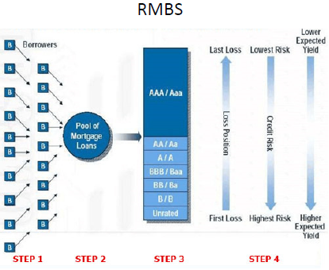



The CDOs are the sum of all equity tranches (B & unrated).

* The CDOs are crappier than the lowest rated real estate mortgage backed securities, but were given a AAA rating.
  + Diversificated 🡪 higher rating even though it is built out of high risk assets.
* CDO2: another financial institution does the same thing as CDO did with the equity tranches of the CDOs.
* Result 🡪 the B-rated in the mortgage pool is less risky than the AAA-rated CDO.

Why do CDO’s work?

* Manager point of view 🡪 only give out low return (so low costs) because ‘low risk’, and no one would buy them anyway.
* Buyers: the package is rated AAA by the rating agencies, so ‘low risk’!

Why was the credit risk underestimated:

* No one expected the entire housing market to collapse all at once.
* Geographic diversification did not reduce risk as much as anticipated – contagion.
* Agency problems with rating agencies: selling ratings for fees, otherwise banks go to competitors.
* Credit Default Swaps (CDS) did not reduce risk as anticipated.
  + CDS: insurance contract against the default of the borrower.
  + Investors bought sub-prime loans and used CDS to insure their safety.
    - “buying insurance on a house that is already on fire”.
  + Big swap issuers did not have enough capital to back their CDS when the market collapsed. The issuers still had to pay the insurance premiums.

Example of CDS failure in The Big Short:

* Investor went $2bn short on B/BB. Had to pay a premium of 5% a year = $100M.
* At the same time, the investor went $15bn long on AAA, thinking they would not fail.
  + However, the AAA appeared to be on a CDO, which is risky. Bankrupt 🡪 big loss.

Systemic Risk: a potential breakdown of the financial system in which problems in one market spill over and disrupt others.

* One default may set off a chain of further defaults.
* Waves of selling may occur in a downward spiral as asset prices drop.
* Potential contagion from institution to institution, and from market to market.

Rise of the systemic risk:

* Banks had a mismatch between the maturity and liquidity of their assets and liabilities.
  + Liabilities were short and liquid.
  + Assets were long and liquid.
  + Constant need to refinance the asset portfolio.
* Banks were highly levered, giving them almost no margin of safety.

How to decrease the odds of a new financial crisis occurring soon:

* Add liquidity to reduce insolvency risk and break a vicious circle of valuation risk/counterparty risk and liquidity risk.
* Increase transparency of structured products like CDS contracts.
* Change incentives to discourage excessive risk-taking and to reduce agency problems at rating agencies.

Dodd-Frank Wall Street Reform and Consumer Protection Act:

* Proposes several mechanisms to mitigate systemic risk.
* The act calls for stricter rules for bank capital, liquidity, and risk management practices.
* More transparency, especially in the derivatives market.

## Lecture 2-4 – boek (CH3)

A primary market issues new securities on an exchange for companies, governments and other groups to obtain financing through debt-based or equity-based securities. Primary markets are facilitated by underwriting groups consisting of investment banks that set a beginning price range for a given security and oversee its sale to investors.

Once the initial sale is complete, further trading is conducted on the secondary market, where the bulk of exchange trading occurs each day.

Types of markets:

* Direct search market: least organized market. Buyers and sellers must seek each other out directly. Example: Craigslist.
* Brokered market: market where buyers and sellers are brought together by agents or intermediaries to facilitate price discovery and transaction execution.
* Dealer market: financial market mechanism wherein multiple dealers post prices at which they will buy or sell a specific security of instrument. In a dealer market, a dealer – who is designated as a “market maker” – provides liquidity and transparency by electronically displaying the prices at which it is willing to make a market in a security, indicating both the price at which it will buy the security (the “bid” price) and the price at which it will sell the security (the “offer” price).
* Auction market: market in which buyers enter competitive bids, and sellers enter competitive offers at the same time. The price at which a stock is traded represents the highest price that a buyer is willing to pay and the lowest price that a seller is willing to sell. Matching bids and offers are then paired together, and the orders are executed.

Types of orders:

* Market orders: buy or sell orders that are to be executed immediately at current market prices.
  + Bid/ask prices.
* Price-contingent orders: an order whose execution depends upon the execution and/or price of another security.
  + Limit buy: buy if and when stock may be obtained at or below a given price.
  + Limit sell: sell if and when stock price rises above a specified limit.
  + Stop-loss: the stock is to be sold if its price falls below a specified limit.
  + Stop-buy: a stock should be bought when its price rises above a limit.



New trading strategies:

* Algorithmic trading: using computer programs to make trading decisions.
  + Traders seek to profit from the bid-ask spread by buying a stock at the bid price and rapidly selling it at the ask price before the price can change.
* High-Frequency trading: subset of algorithmic trading that relies on computer programs to make extremely rapid decisions.
  + Traders compete for trades that offer very small profits.
* Dark pools give investors the opportunity to place orders and make trades without publicly telegraphing their intentions until the sale has been executed. They are mostly used by institutional investors for block trades involving a large number of securities.

Short position: investment strategy where the investor sells shares of borrowed stock in the open market. The expectation of the investor is that the price of the stock will decrease over time, at which point the he will purchase the shares in the open market and return the shares to the broker which he borrowed them from.

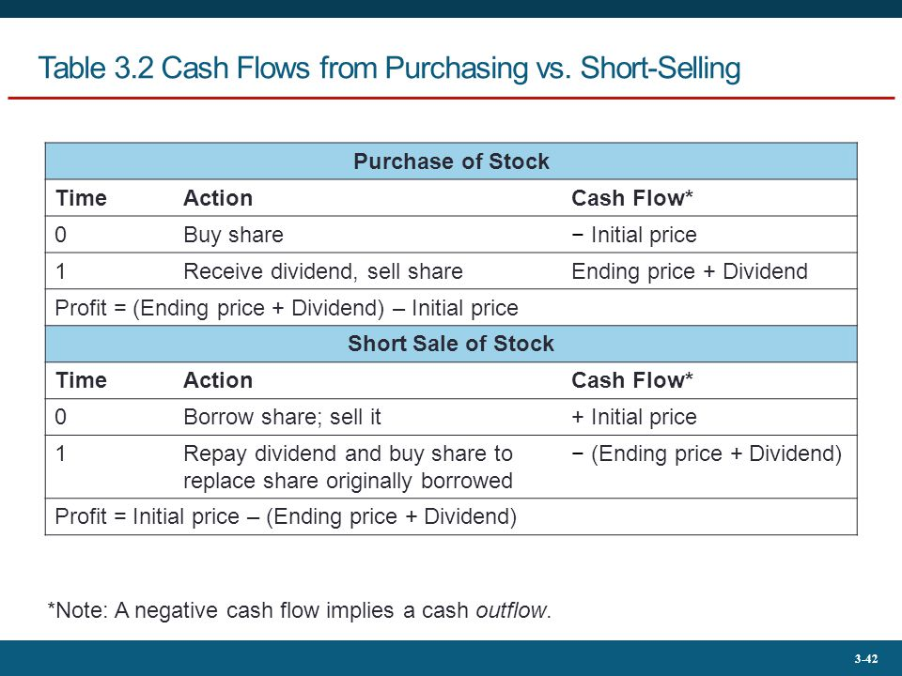

Tabel - Cash Flows from Purchasing versus Short-Selling Shares of Stock

Summary CH3:

Firms issue securities to raise the capital necessary to finance their investments. Investment bankers market these securities to the public on the primary market. Investment bankers generally act as underwrites who purchase the securities from the firm and resell them to the public at a mark-up. Before the securities may be sold to the public, the firm must publish an SEC-accepted prospectus that provides information on the firm’s prospects.

Already-issued securities are traded on the secondary market, that is, on organized stock markets; on the over-the-counter market, and occasionally for very large trades, through direct negotiation. Only license holders of exchanges may trade on the exchange. Brokerage firms holding licenses to trade on the exchange sell their services to individuals, charging commissions for executing trades on their behalf.

Trading may take place in dealer markets, via electronic communication networks, or in specialist markets. In dealer markets, security dealers post bid and ask prices at which they are willing to trade. Brokers for individuals execute trades at the best available prices. In electronic markets, the existing book of limit order provides the terms at which trades can be executed. Mutually agreeable offers to buy or sell securities are automatically crossed by the computer system operating the market. In specialist markets, the specialist acts to maintain an orderly market with price continuity. Specialists maintain a limit-order book, but also sell from or buy for their own inventories of stock.

Buying on margin means borrowing money from a broker to buy more securities than can be purchased with one’s own money alone. By buying securities on margin, an investor magnifies both the upside potential and the downside risk. If the equity in a margin account falls below the required maintenance level, the investor will get a margin call from the broker.

Short-selling is the practice of selling securities that the seller does not own. The short-seller borrows the securities sold through a broker and may be required to cover the short position at any time on demand. The cash proceeds of a short sale are kept in escrow by the broker, and the broker usually requires that the short-seller deposit additional cash or securities to serve as a margin or collateral.

Securities trading is regulated by the Securities and Exchange Commission (SEC), by other government agencies, and through self-regulation of exchanges. Many of the important regulations have to do with full disclosure of relevant information concerning the securities in question. Insider trading rules also prohibit traders from attempting to profit from inside information.

## Lecture 5 –slides

Investment companies are financial intermediaries that collect funds from individual investors, and invest those funds in a potentially wide range of securities and other assets.

* Advantage: pooling of assets reduces transaction costs.
* Each individual investor has a claim in proportion to the amount invested.

Services of investment companies:

* Administration and record keeping: issuing periodic status reports, keeping track of capital gains distributions, dividends, investments, and redemptions.
* Diversification and divisibility.
* Professional management: support full-time stags of security analysts and portfolio managers who attempt to achieve superior investment results for their investors.
* Reduced transaction costs.
* Keep track of information (economics of scale).
  + Knowledge ↑ 🡪 more accurate expectation of the future 🡪 higher expected return.

Net Asset Value:

* This ratio is used as a basis for valuation of investment company shares.
  + Reasons for value calculations: (i) selling new shares and (ii) redeeming existing shares.

Types of Investment Organizations:

* Unit trusts: pools of money invested in a portfolio that is fixed for the life of the fund.
* Managed investment companies.
  + Open-end (strictly regulated): mutual fund companies which sell and redeem shares at the net asset value per share.
    - Front-end load: giving up around 8% of your initial investment on fees.
    - Back-end load: giving up around 5% of your earnings when you want to exit. Reasoning: when someone pulls money out, the manager could have to sell parts of portfolio – sometimes at a loss.
    - Operating expenses: paying 2% through reduced value of portfolio for manager to live from, and to pay travel expenses.
    - Pricing: net asset value.
  + Closed-end: an investment-management company that sells a limited number of shares to investors on an exchange by way of an initial public offering.
    - Pricing: premium or discount to NAV.
      * Discount=profit if market price < NAV.
* Exchange-Traded Funds.
  + ETF: a marketable security that tracks an index, a commodity, bonds, or a basket of assets like an index fund.
  + ETFs trade continuously whereas mutual fund shares can only be traded once a day.
  + High liquidity, and lower fees than mutual fund shares. But also a lower expected return through a lower risk premium.
  + Becoming more and more popular.

Types of Investment Organizations (cont..):

* Other investment organizations.
  + REITs: similar to closed-end fund, invest in real estate or loans secured by real estate.
  + Hedge funds: alternative investments using pooled funds that employ numerous different strategies to earn active return, or alpha, for their investors.

Empirical evidence of fund performance:

* The average mutual fund performance is generally less than the broad market performance.
  + Active mutual funds vs Wilshire 5000 graph.
  + Mutual funds managers advertise their funds according to their performance.
    - If doing better than market, but still losing: “outperforming market”.
    - If doing worse than market, but gaining: “fund is doing well, high return”.
* The evidence that performance is consistent from one period to the next is suggestive, but inconclusive.
  + Depends on measurement interval.
  + Depends on time period.

Window dressing by mutual fund managers:

* Mutual funds are required to report their assets holdings every quarter.
  + This has to be done in order to be ‘listed’. Higher listed 🡪 attracts more investors.
  + (mutual funds are not allowed to go short).
* Definition of window dressing: Managers altering or distorting their portfolios in an attempt to mislead investors about their true ability by disclosing disproportionately higher (lower) holdings in stocks that have done well (poorly) over a reporting period.
* The fund manager will sell stocks with large losses and purchase high flying stocks near the end of the quarter. These securities are then reported as part of the fund's holdings.

Example of window dressing:

* Apple goes up by 5% in one period.
* Shell goes down by 2% in one period.
* At t=0, mutual fund holds Shell but not Apple.
* (i) At t=1, holding Shell will appear to show poor performance over time.
* (ii) At t=1, having sold Shell and having bought Apple will appear to show good performance.
* Window dressing occurs in case (ii).
  + When the manager realises that Apple does better than Shell, the manager trades the stocks in order to have Apple but not Shell. The effect on the return of that very period is not affected by this trade. However, the fund will look more attractive to potential investors.

Morningstar writes analyst reports on funds, and rates them with stars (1-5).

* Value stocks: low ratios of market price per share – stocks have a low market price relative to their book value.
* Growth stocks: high ratios of market price per share – investors must believe firm will experience rapid growth to justify the prices at which stock sell.
* Size: small vs large. Smaller firms are riskier to invest in, but you get rewarded for investing in small firms.

|  |  |  |  |
| --- | --- | --- | --- |
| **Style Box** | Value | Blend | Growth |
| Large |  |  |  |
| Medium |  |  |  |
| Small |  |  |  |

Black box indicates which firm you try to outperform.

Taxes and inflation:

* Taxes are paid on nominal income.
* Example: investor A is in the 30% tax bracket and the investment yields 8%. Inflation is 4%.
  + Real return: 4% 🡪 after tax:
  + Nominal return: 8% 🡪 after tax: % (only 1.6% above inflation).

## Lecture 6 – slides

One period holding period return:

* : holding period return.
* : beginning price.
* : ending price.
* : dividend during period t+1.

Average annual return:

Variance:

Standard deviation:

Historical returns of stocks and bonds.

* Historical returns can be calculated by counting the number of times a realized return falls within a particular range 🡪 estimate underlying probability distribution.
* Empirical distribution: when the probability distribution is plotted using historical data.
  + Only takes into account what has happened.
  + Problem: extremes that have not yet happened are not taken into account.

When an investment is risky, it implies that there are different returns it may earn (in every state of the world). Each possible return has some likelihood of occurring.

This information is summarized with a probability distribution, which assigns a probability that each possible return will occur.

Probability distribution:

Expected return:

Variance:

Standard deviation:

Example:

Price of BFI stock: $100.

P=0.25 🡪 price becomes $140

P=0.50 🡪 price becomes $110

P=0.25 🡪 price becomes $80

Expected price: $110.

Variance:

Standard deviation: 0.7036

* Volatility: measurement of risk.

Risk premium: the difference between the expected holding period return on the stock and the risk free rate.

Excess return: the difference in any particular period between the actual rate of return on a risky asset and the risk free rate.

The risk premium is the expected excess return.

Characteristics of probability distributions:

* Mean: the most likely value.
* Standard deviation: risk.
* Skewness: left or right / negative or positive.
  + Positively skewed: frequent small negative outcomes, few extreme gains.
  + Negatively skewed: frequent small gains, few extreme losses.
* Kurtosis: fat tails.
  + The fatter, the higher the probabilities that extremes occur.

In case of a normal distribution, the third and fourth moments do not matter.

Speculation is the assumption of considerable investment risk to obtain commensurate gain.

* Considerable risk: the risk is sufficient to affect the decision. An investor might reject an investment that has a positive risk premium because the potential gain is insufficient to make up for the risk involved.
* Commensurate gain: a positive risk premium, an expected profit greater than the risk-free alternative.

Gambling is to bet or wager on an uncertain outcome.

A gamble is the assumption of risk for no purpose but enjoyment of the risk itself, whereas speculation is undertaken in spite of the risk involved because one perceives a favourable risk-return trade-off.

To turn a gamble into a speculative prospect requires an adequate risk premium to compensate risk-averse investors for the risk they bear.

A risky investment with a risk premium of zero amounts to a gamble, and a risk-averse investor will reject it.

Risk-averse investors are only willing to consider risk-free or speculative prospects with positive risk premiums.

## Lecture 7 – slides

Risk management is the identification, assessment, and prioritization of risks followed by coordinated and economical application of resources to minimize, monitor, and control the probability and/or impact of unfortunate events or to maximize the realization of opportunities.

* Risk management’s objective is to assure uncertainty does not deflect the endeavour from the business goals.

Risk management is important for individual investors, regulatory supervisors.

Change for pension funds:

* Before: value liabilities with a fixed discount percentage.
* Now: value liabilities on fair value.

Returns for many asset classes can well be approximated by the normal distribution.

* But beware: ‘fatter tails’ for returns means that outliers are more likely.

Assumption:

Value at risk (VaR) is a statistical technique used to measure and quantify the level of financial risk within a firm or investment portfolio over a specific time frame.

* Provides a lower bound on the amount that you are going to lose with a certain probability.

Assumption: VaR = 5% 🡪

Assumption:

Implications of

* Two effects:
  + Time-diversification: also called the standard deviation effect.
  + Expected return effect: the longer the horizon, the more dominant the impact of the expected return will be.
* Giving a lower bound on the amount that you are going to lose with a certain probability.
* is how much you will certainly have left with 95% probability.
* Example: , then with 95% probability I will have at least 79 left after 1 period.
* Higher confidence intervals include more losses on the portfolio, but gives you a higher probability that you have at least a given amount.
* For large firms: normal approximation leads to a good assessment.
* Small firms: normal approximation overestimates risk 🡪 large losses would occur at higher probability than they actually do.

Taylor Approximation:

Assumption:



Calculating the return for 1 year (divided into 4 quarters):

* The annual return is the sum of all quarterly returns.

Calculating the annual using quarterly data:

Problem of using VaR: it does not satisfy the conditions of a coherent risk measure.

* It is possible to construct portfolios for which the VaR is larger than the sum of the VaRs of the individual components.

Alternative: Expected Shortfall.

* Expected shortfall focuses on the expected loss in the worst-case scenario.
* The "expected shortfall at q% level" is the expected return on the portfolio in the worst q% of cases.
* Estimates the risk of an investment in a conservative way, focusing on the less profitable outcomes.

GUISE: gemiddelde uitbetaling in slechte eventualiteiten.

* Calculates the average return in the q% worst case scenarios.

Example: 10% Guise 🡪

* Where:

* is to be found in the table with cumulative normal distribution functions.

Example from slides:

* If I invest 1000 now, in the 10% worst cases I will have:
  + 881.54 left after 1 year.
  + 940.56 left after 5 years.

Geometric average vs Arithmetic average:

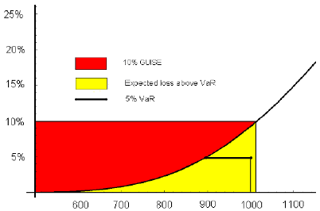

Mean Variance Utility Function:

* utility.
* expected return.
* coefficient of risk aversion (high A 🡪 risk averse 🡪 steeper indifference curve)
* variance of returns.

One can read the utility from a given risky investment by drawing the indifference curve for that person, and reading the utility on the y-axis when x=0.

## Lecture 5-7 – boek (CH4)

Unit investment trusts, closed-end management companies, and open-end management companies are all classified and regulated as investment companies.

* Unit investment trusts are essentially unmanaged in the sense that the portfolio, once established, is fixed.
* Managed investment companies, in contrast, may change the composition of the portfolio as deemed fit by the portfolio manager.
* Closed-end funds are traded like other securities: they do not redeem shares for their investors.
* Open-end funds will redeem shares for net asset value at the request of the investor.

Net asset value equals the market value of assets held by a fund minus the liabilities of the fund divided by the shares outstanding.

Mutual funds free the individual from many of the administrative burdens of owning individual securities and offer professional management of the portfolio. They also offer advantages that are available only to large-scale investors, such as discounted trading costs.

On the other hand, funds are assessed management fees and incur other expenses, which reduce the investor’s rate of return.

Funds also eliminate some of the individual’s control over the timing of capital gain realizations.

Mutual funds are often categorized by investment policy. Major policy groups include money market funds; equity funds, which are further grouped according to emphasis on income versus growth; fixed-income funds; balanced and income funds; asset allocation funds; index funds; and specialized sector funds.

Costs of investing in mutual funds include front-end loads, which are sales charges; back-end loads, which are redemption fees or, more formally, contingent-deferred sales charges; fund operating expenses; and 12b-1 charges, which are recurring fees used to pay for the expenses of marketing the fund to the public.

The average rate of return of the average equity mutual fund in the last four decades has been below that of a passive index fund holding a portfolio to replace a broad-based index like the S&P 500 or Wilshere 5000. Some of the reasons for this disappointing record are the costs incurred by actively managed funds, such as the expense of conducting a research to guide stock-picking activities, and trading costs due to higher portfolio turnover.

The record on the consistency of fund performance is mixed. In some sample periods, the better performing funds continue to perform well in the following periods; in other sample periods they do not.

## Lecture 8 – slides

**Markowitz Portfolio Theory**

Case 1) Combining 1 risky asset with a risk free asset.

Portfolio *p*: Risk free rate:

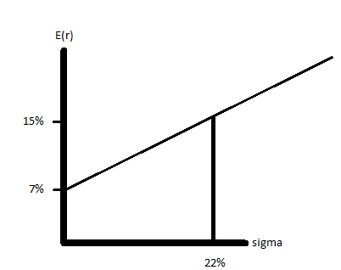

Slope of the line:

* The expected risk premium obtained for each unit of risk.
* The slope does not depend on one’s risk aversion.
* Also called the reward-to-volatility ratio.

Note: one can also borrow money from the bank at the 7% rate, and invest that in the risky asset.

* This investor would be at the top right of the point of 15% expected return and 22% risk.

Finding the optimal portion to invest in risk free and risky assets:

Maximize Utility:

Implication: higher risk aversion (A) 🡪 lower 🡪 more in risk free asset, less in the risky asset.

higher risk aversion (A) 🡪 steeper indifference curve.

In this case: Suppose A =4, then this is the utility function for every y.

Graphical representation of utility levels at each allocation to the risky asset.

Notice that the interception of this indifference curve is simply the certainty equivalent of the portfolio.

* The utility value of a risk-free portfolio is simply the expected rate of return of that portfolio.

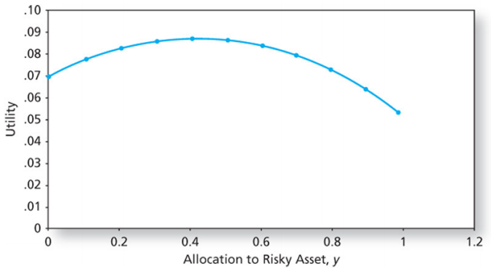

**Markowitz Portfolio Theory**

Case 2) Combining two risky assets.

When we hold a well-diversified portfolio, the contribution to portfolio risk of a particular security will depend on the covariance of that security’s return with those of the other securities and not on the security’s variance.

Assumptions:

* : All variances are the same.

Then, in general we have:

Suppose we have equal weights:

Where:

When N goes to infinity:

* goes to zero.
* goes to .
* Summed up: it only matters what the covariance between the assets is, the risk of one asset is no longer of importance.
* If the covariance is low or negative, the goes down and this allows for diversification opportunities.

Low correlation allows for diversification opportunities.

## Lecture 9 – slides

## Lecture 10 – slides

## Lecture 8-10 – boek (CH6 and CH7)

## Lecture 8-10 – reader

## Lecture 11 – slides

## Lecture 11 – boek (CH9)